**BLG 202E – Numerical Methods in CE**

**Spring 2017**

**Assignment – 2**

**Due: 09.04.2017 23:59**

**Question 1 – Gaussian Elimination and Backward Substitution**

$$x_{1}-x_{2}+3x_{3}=2$$

$$x_{1}+x_{2}=4$$

$${3x}_{1}-{2x}_{2}+x_{3}=1$$

$$(A | b)⇒\left(\begin{matrix}1 & -1 & 3 \\ 1 & 1 & 0 \\ 3 & -2 & 1\end{matrix} | \begin{aligned}2 \\ 4 \\ 1\end{aligned}\right) ⇒ \left(\begin{matrix}1 & -1 & 3 \\ 0 & 2 & -3 \\ 0 & 1 & -8\end{matrix} | \begin{aligned}2 \\ 2 \\ -5\end{aligned}\right)⇒\left(\begin{matrix}1 & -1 & 3 \\ 0 & 1 & -8 \\ 0 & 2 & -3\end{matrix} | \begin{aligned}2 \\ -5 \\ 2\end{aligned}\right)⇒\left(\begin{matrix}1 & -1 & 3 \\ 0 & 1 & -8 \\ 0 & 0 & 13\end{matrix} | \begin{aligned}2 \\ -5 \\ 12\end{aligned}\right)$$

(Gaussian elimination)

$$x_{3}=\frac{12}{13} , x_{2}=\left(-5+8*\frac{12}{13} \right)=\frac{31}{13} , x_{1}=\left(2+\frac{31}{13}-3*\frac{12}{13}\right)=\frac{21}{13}$$

(Backward substitution)

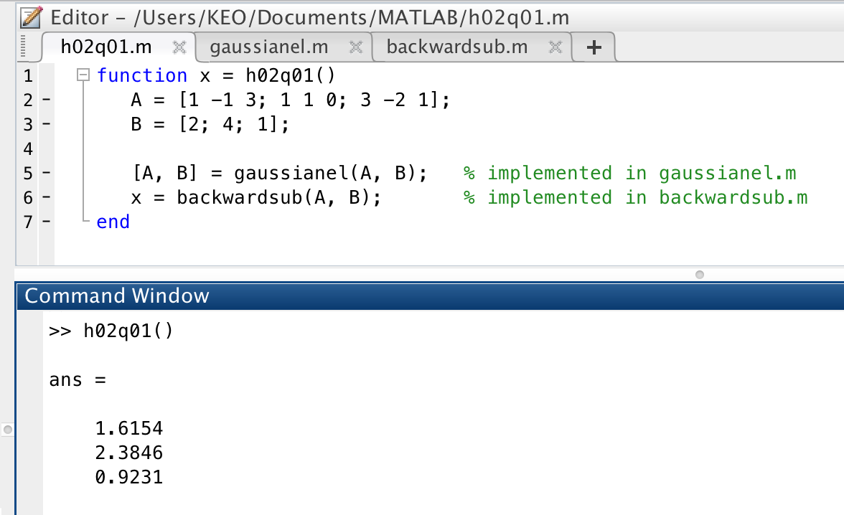

(Figure 1: Implementation of Gaussian elimination and backward substitution)

The results calculated manually and calculated with matlab are exactly the same. The matlab scripts are attached to zip file (h02q01.m, gaussianel.m, and backwardsub.m)

**Question 2 – LU Decomposition**

$Ax=b$

$LUx=b$

$A=\left[\begin{matrix}1 & 2 & 4 \\ 3 & 8 & 14 \\ 2 & 6 & 13\end{matrix}\right]$

$l_{21}= \frac{3}{1}=3, l_{31}= \frac{2}{1}=2 ⇒ M^{(1)}=\left(\begin{matrix}1 & 0 & 0 \\ -3 & 1 & 0 \\ -2 & 0 & 1\end{matrix}\right), A^{(1)}=M^{(1)}*A=\left(\begin{matrix}1 & 2 & 4 \\ 0 & 2 & 2 \\ 0 & 2 & 5\end{matrix}\right)$

$$l_{32}= \frac{2}{2}=1 ⇒ M^{(2)}=\left(\begin{matrix}1 & 0 & 0 \\ 0 & 1 & 0 \\ 0 & -1 & 1\end{matrix}\right), U=A^{(2)}=M^{(2)}*A^{(1)}=\left(\begin{matrix}1 & 2 & 4 \\ 0 & 2 & 2 \\ 0 & 0 & 3\end{matrix}\right)$$

$$L=\left(\begin{matrix}1 & 0 & 0 \\ l_{21} & 1 & 0 \\ l_{31} & l_{32} & 1\end{matrix}\right)=\left(\begin{matrix}1 & 0 & 0 \\ 3 & 1 & 0 \\ 2 & 1 & 1\end{matrix}\right)$$

Assume that we have many right-hand side vectors to find to solutions. We have to apply Gaussian elimination method for every right-hand side vector separately which costs $O\left(n^{3}\right)$ flops and backward substitution which costs $O\left(n^{2}\right)$. But at LU decomposition method, we just have to apply LU decomposition which costs $O\left(n^{3}\right)$ flops for ones, and then for each right-hand side vector we apply backward substitution ($O\left(n^{2}\right)$).

1. 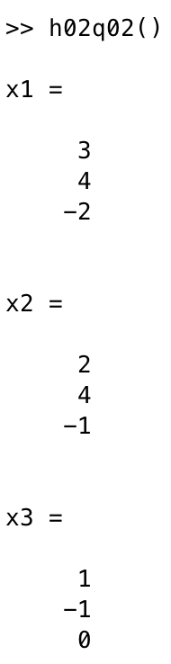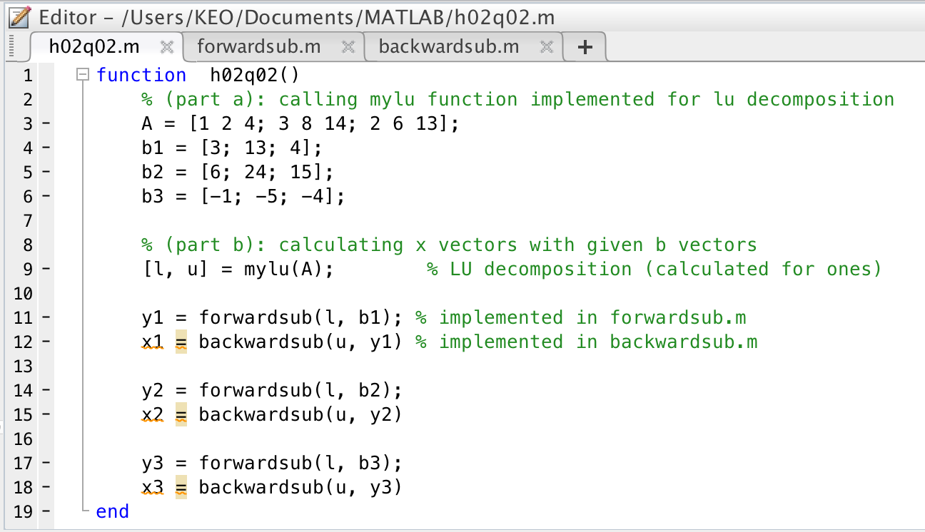The implementation of LU decomposition in matlab is attached to zip file and used in h02q02.m

(Figure 2.1, 2.2: Implementation of LU decomposition and x vectors for given b vectors)

**Question 3 – Pivoting**

$$A=\left[\begin{matrix}5 & 6 & 7 & 8 \\ 0 & 4 & 3 & 2 \\ 0 & 0 & 0 & 1 \\ 0 & 0 & -1 & -2\end{matrix}\right]$$

1. $PA=LU$, $U=A^{(3)}={M^{(3)}*P}^{(3)}*{M^{\left(2\right)}*P}^{\left(2\right)}*{M^{\left(1\right)}*P}^{\left(1\right)}*A$

$P^{(1)}=P^{(2)}=M^{(1)}=M^{(2)}=I (identity matrix)$, so we do not have to apply these steps.

So we obtain this equation: $U=A^{(3)}={M^{(3)}*P}^{(3)}*A$

$P^{(3)}=\left[\begin{matrix}1 & 0 & 0 & 0 \\ 0 & 1 & 0 & 0 \\ 0 & 0 & 0 & 1 \\ 0 & 0 & 1 & 0\end{matrix}\right]$, $P^{(3)}*A= \left[\begin{matrix}5 & 6 & 7 & 8 \\ 0 & 4 & 3 & 2 \\ 0 & 0 & -1 & -2 \\ 0 & 0 & 0 & 1\end{matrix}\right]$

And at this stage it can be observed $M^{(3)}$ is also identity matrix, so we can delete this from equation.

$$U=A^{(3)}=P^{(3)}*A=\left[\begin{matrix}5 & 6 & 7 & 8 \\ 0 & 4 & 3 & 2 \\ 0 & 0 & -1 & -2 \\ 0 & 0 & 0 & 1\end{matrix}\right] L=\left[\begin{matrix}1 & 0 & 0 & 0 \\ 0 & 1 & 0 & 0 \\ 0 & 0 & 1 & 0 \\ 0 & 0 & 0 & 1\end{matrix}\right] P=\left[\begin{matrix}1 & 0 & 0 & 0 \\ 0 & 1 & 0 & 0 \\ 0 & 0 & 0 & 1 \\ 0 & 0 & 1 & 0\end{matrix}\right]$$

b = $\left[\begin{matrix}26 \\ 9 \\ 1 \\ -3\end{matrix}\right], Ax=b$

$$(A | b)⇒\left(\begin{matrix}5 & 6 & 7 & 8 \\ 0 & 4 & 3 & 2 \\ 0 & 0 & 0 & 1 \\ 0 & 0 & -1 & -2\end{matrix} | \begin{matrix}26 \\ 9 \\ 1 \\ -3\end{matrix}\right)⇒\left(\begin{matrix}5 & 6 & 7 & 8 \\ 0 & 4 & 3 & 2 \\ 0 & 0 & -1 & -2 \\ 0 & 0 & 0 & 1\end{matrix} | \begin{matrix}26 \\ 9 \\ -3 \\ 1\end{matrix}\right)$$

(Gaussian elimination: $A_{43}$ is chosen as pivot and exchange rows 4 and 3)

$$x_{4}=1 , x_{3}=\frac{\left(-3-\left(-2\right)*1 \right)}{-1}=1 ,$$

$$x_{2}=\frac{9-2*1-3*1}{4}=1, x_{1}=\frac{26-8*1-7*1-6*1}{5}=1$$

$$x=\left[\begin{matrix} 1 \\ 1 \\ 1 \\ 1 \end{matrix}\right]$$

**Question 4 – Data Compression and Truncated SVD**

In this question, I wrote a matlab code (h02q04.m) to compute truncated SVD of the image with various ranks. I can be observed that the cuteness of image and r values increase proportionally. Images for all r values were saved in Images folder.

function h02q04()

X = imread('cute.jpg');

G = rgb2gray(X);

D = im2double(G);

[U,S,V] = svd(D);

for r = 10 : 5 : 30

reduced = U(:,1:r)*S(1:r,1:r)*V(:,1:r)';

figure, imshow(reduced); % Copied in Images folder

end

end

Kadir Emre Oto

150140032

otok@itu.edu.tr